**PYTHON FUNDAMENTALS**

1. **PYTHON COMMENTS**

A hash sign (#) that is not inside a string literal is the beginning of a comment. All characters after the #, up to the end of the physical line, are part of the comment and the Python interpreter ignores them.

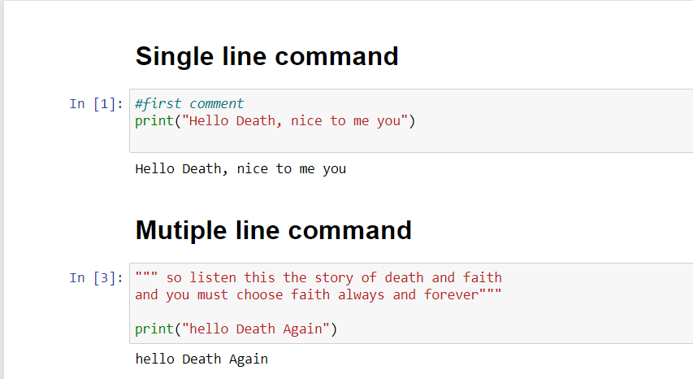

1. **PYTHON KEYWORDS**

The following list shows the Python keywords. These are reserved words and you cannot use them as constants or variables or any other identifier names. All the Python keywords contain lowercase letters only.

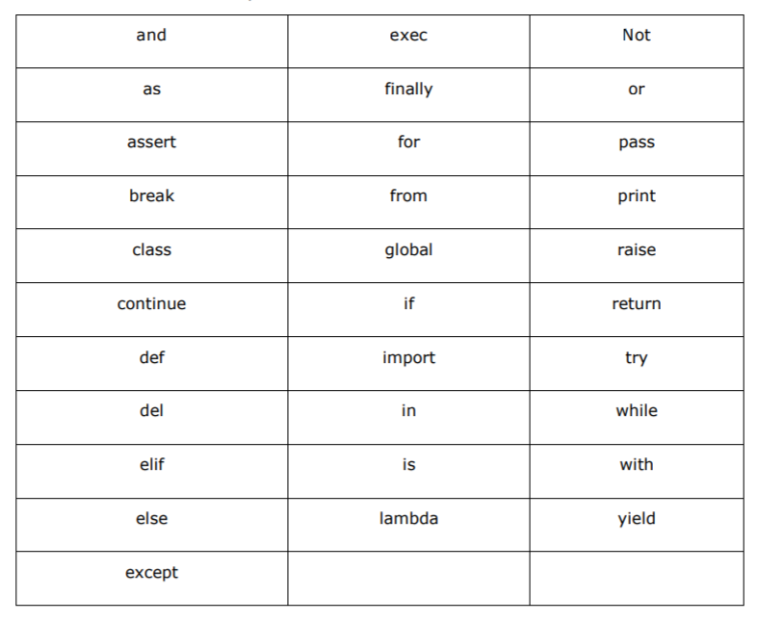

1. **PYTHON IDENTIFIERS**

A Python identifier is a name used to identify a variable, function, class, module or other object. An identifier starts with a letter A to Z or a to z or an underscore (_) followed by zero or more letters, underscores and digits (0 to 9).

Python does not allow punctuation characters such as @, $, and % within identifiers. Python is a case sensitive programming language. Thus, Manpower and manpower are two different identifiers in Python.

Here are naming conventions for Python identifiers-

• Class names start with an uppercase letter. All other identifiers start with a lowercase letter.

• Starting an identifier with a single leading underscore indicates that the identifier is private. Python 3 15

• Starting an identifier with two leading underscores indicates a strong private identifier.

• If the identifier also ends with two trailing underscores, the identifier is a language defined special name.

**PYTHON INPUT AND OUTPUT**

**Reading Input from Keyboard**

Python 2 has two versions of input functions, input () and raw_input (). The input() function treats the received data as string if it is included in quotes '' or "", otherwise the data is treated as number.

In Python 3, raw_input () function is deprecated. Further, the received data is always treated as string.

**TO CONVERT**

1. **String into integer we can use int()**
2. **String into integer we can use float()**

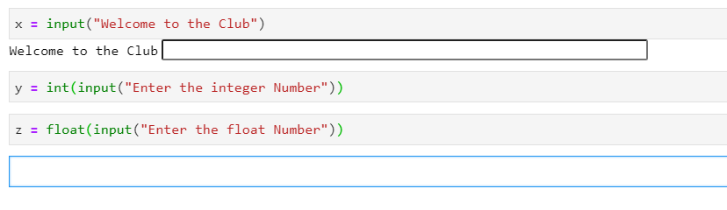

**OUTPUT**

Most notable and most widely known change in Python 3 is how the print function is used. Use of parenthesis () with print function is now mandatory. It was optional in Python 2.

print "Hello World" #is acceptable in Python 2

print ("Hello World") # in Python 3, print must be followed by ()